TASK REPORT

Submitted to

MyCaptain

Course Name: Data Analytics With Python

Task no.2 : AI-Assisted Python Analysis Challenge

Prepared by

Deepthi Chenthil Kumar Nadar

Table of Contents
Sr. No. | Section | Page No.
1 | Project Overview | 1
3 | Dataset Inspection | 2
4 | Data Cleaning | 2
5 | Data Transformations | 3
6 | Business Analysis | 4
8 | How AI Helped | 6

GitHub link: AI Business Question & Data Quality Sprint

1. Project Overview

Dataset Description

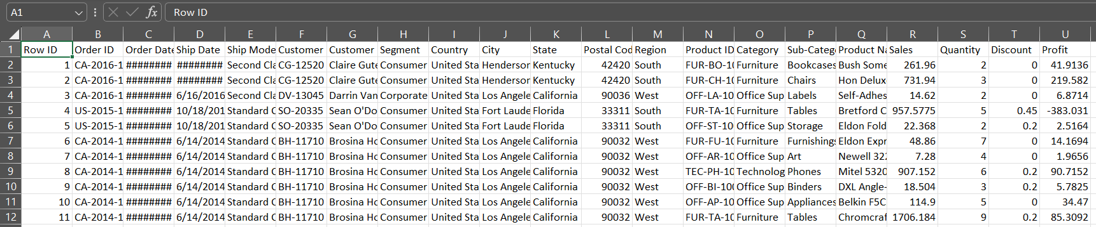
This project uses the Superstore Sales dataset containing 9,994 sales transactions across different regions, customer segments, product categories, and shipping methods. The dataset includes information such as sales, profit, discount, quantity, customer details, and order dates.

Who Uses This Data?
This type of data is commonly used by:
- Retail businesses
- Sales managers
- Business analysts
- Marketing teams
- Supply chain teams

Business Decisions Supported
The dataset can help organizations:
- Identify profitable products and regions
- Evaluate discount strategies
- Understand customer purchasing behavior
- Improve inventory planning
- Increase overall profitability

2. Dataset Inspection

Dataset Size
- Rows: 9,994
- Columns: 21

Initial Inspection Performed
- Checked data types using df.info()
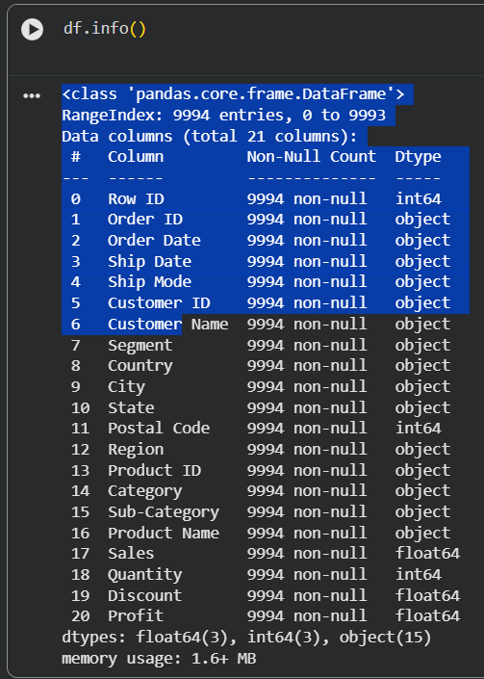
- Examined sample records using df.head()
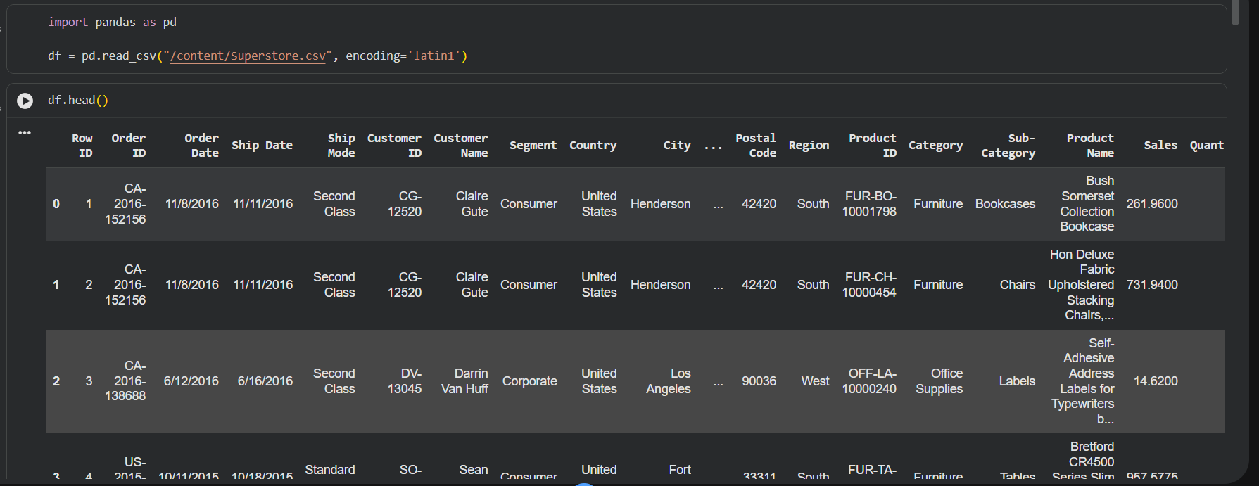
- Checked for missing values using df.isnull().sum()
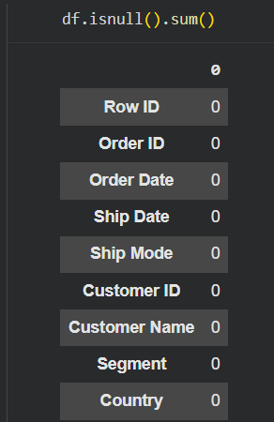
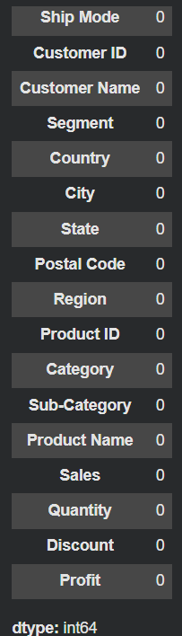

3. Data Cleaning

Issues Identified
- Order Date and Ship Date were stored as object data types.
- Duplicate records were checked.
- Missing values were inspected.
- Column names and formatting were reviewed for consistency.

Cleaning Steps Performed
- Converted Order Date to datetime format.
- Converted Ship Date to datetime format.
- Checked and removed duplicates if present.
- Verified that no significant missing values existed.

4. Data Transformations

Transformation 1: Created Year Column
Extracted year from Order Date to perform yearly sales analysis.

Transformation 2: Created Month Column
Extracted month from Order Date to analyze seasonal sales patterns.

Transformation 3: Grouped Data by Category and Region
Aggregated sales and profit values to identify business trends.

Transformation 4: Customer Segment Analysis
Grouped customer segments to compare purchasing behavior.

- Business Analysis
1. Which product category generates the highest total sales?
Businesses need to know which categories bring the most revenue so they can focus marketing and inventory investments there.
Business Impact
- Better inventory planning
- Increased marketing focus
- Revenue optimization
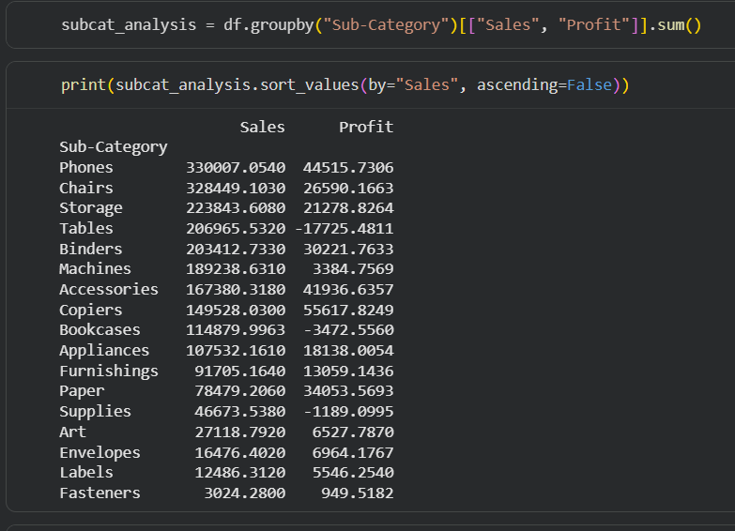

2. Which sub-category is the least profitable despite high sales?
Some products sell a lot but still generate low profit because of discounts or high operational costs.
Business Impact
- Identify loss-making products
- Improve pricing strategy
- Reduce unnecessary discounts
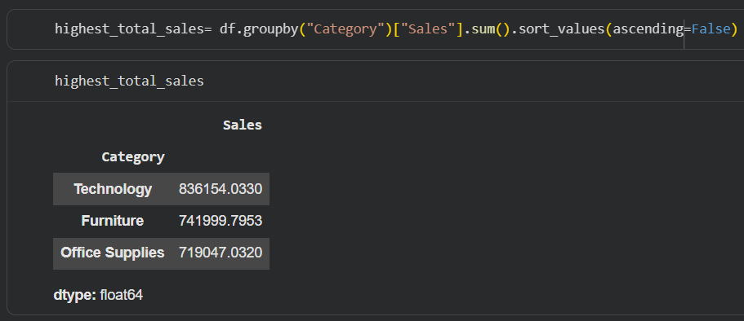

3. Which region contributes the highest profit?
Companies need to understand which locations perform best financially.
Business Impact
- Expansion planning
- Regional investment decisions
- Better resource allocation
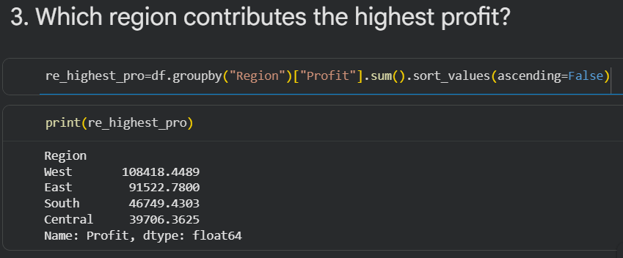

4. Which states are generating losses?
Even if total company profit is positive, some states may be underperforming.
Business Impact
- Detect risky markets
- Improve regional strategy
- Reduce operational losses
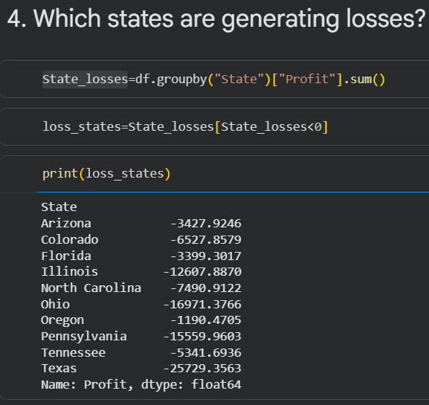

6. Which customer segment generates the highest average order value?
Some customer groups may purchase less frequently but spend more per order.
Business Impact
- Premium customer identification
- Personalized marketing
- Upselling opportunities
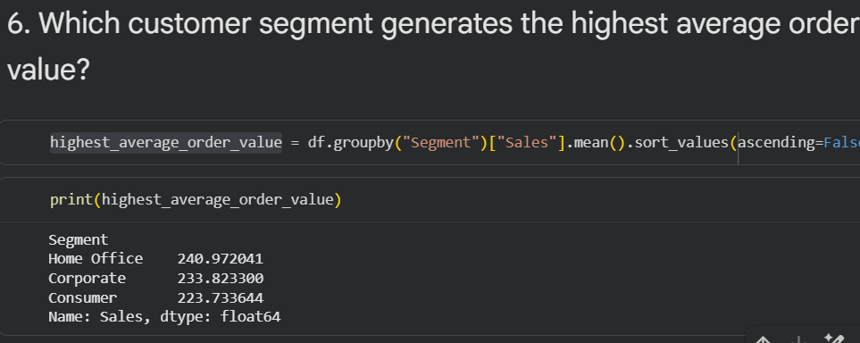

Discount & Profit Analysis

7. Does giving higher discounts reduce profit?
Discount strategies can increase sales but may hurt profitability.
Business Impact
- Smarter discount policies
- Profit optimization
- Better pricing decisions
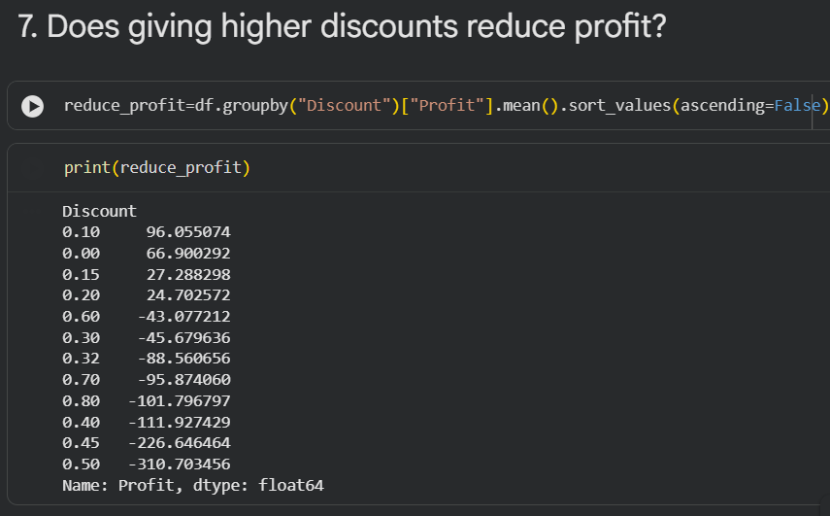

8. Which products receive high discounts but still perform poorly?
Some products fail even after aggressive discounting.
Business Impact
- Remove weak products
- Reduce unnecessary promotions
- Improve sales strategy

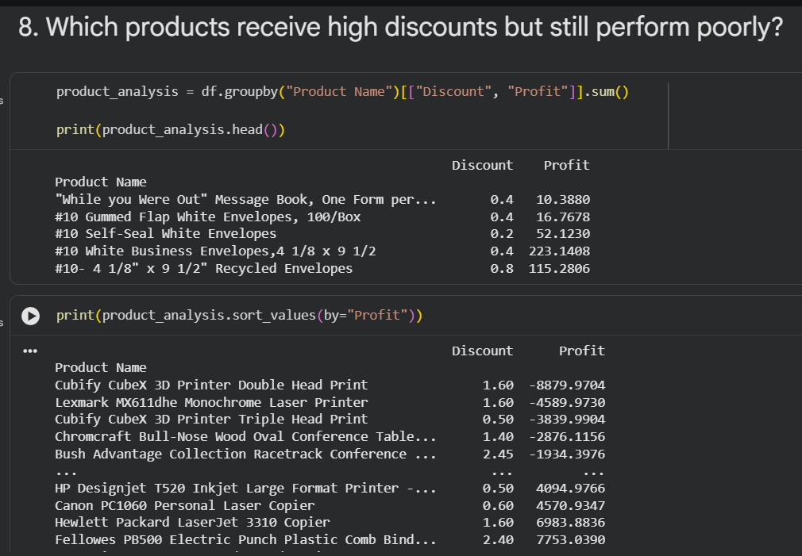

Time-Based Analysis

9. Which month had the highest sales?
Businesses need to identify seasonal trends.
Business Impact
- Seasonal inventory planning
- Festival sales preparation
- Staffing optimization

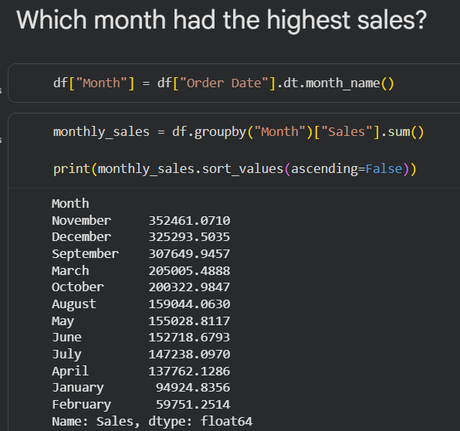

10. Which year showed the highest business growth?
Tracking yearly growth helps evaluate company performance.
Business Impact
- Strategic planning
- Investment decisions
- Performance tracking

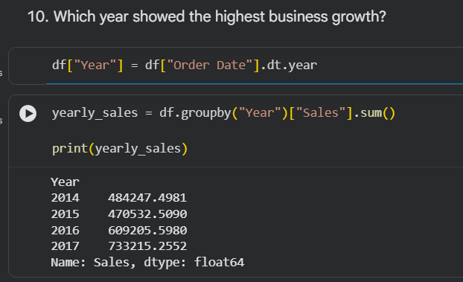

6. How AI Helped
AI was used as a support tool during the project. It assisted in:
- Suggesting suitable Pandas functions.
- Debugging Python code.
- Improving code comments and documentation.
- Explaining business analysis concepts.
All cleaning decisions, transformations, and final business conclusions were verified and performed manually after reviewing the dataset.

